**A**

**REPORT ON**

**“Data Analysis and Preprocessing of Fragile States Index”**

**Submitted by:**

**Vaishnavi Shevate (2124UDSF2005)**

**Vedant Mavale (2124UDSM2006)**

**Harshal Gadekar(2124UDSM2007)**

**Gauri Lad(2124UDSM2008)**

**Under Guidance of:**

**Dr. Vengat Vengatesan**



**DEPARTMENT ARTIFICIAL INTELLIGENCE & DATA SCIENCE SANJIVANI UNIVERSITY**

**School of Engineering & Technology (SET) 2024-25**

**DEPARTMENT ARTIFICIAL INTELLIGENCE & DATA SCIENCE SANJIVANI UNIVERSITY**

**School of Engineering & Technology (SET)**



**CERTIFICATE**

This is to certify that the seminar report is entitled

**“Data Analysis and Preprocessing of Fragile States Index”**

**Submitted by:**

**Vaishnavi Shevate (2124UDSF2005)**

**Vedant Mavale (2124UDSM2006)**

**Harshal Gadekar(2124UDSM2007)**

**Gauri Lad(2124UDSM2008)**

is a record of bonafide work carried out by her under the supervision and guidance of **Dr. Vengat Vengatesan** in partial fulfillment of the requirement for **Second Year** (AIDS) of School of Engineering & Technology, Sanjivani University in the academic year 2024-2025.

**Date:**

**Place: Kopargaon**

**Dr. Vengat Vengatesan Dr. Kavitha Rani**

**(Head of Department) (Dean, SET SU)**

**Abstract:**

The Fragile States Index (FSI) is an annual report compiled by the Fund for Peace, which ranks countries based on their vulnerability to conflict or collapse. The index is based on a variety of indicators spanning political, economic, and social factors, including measures such as poverty, human rights, and social unrest. This report explores the 2024 FSI dataset, analyzing its features, performing data preprocessing and visualization, and discussing outliers. The findings suggest that countries with higher FSI scores often struggle with governance and development, facing systemic challenges.

**Introduction:**

The Fragile States Index (FSI) is a key tool for assessing the stability and resilience of countries. It provides a comprehensive snapshot of the factors contributing to state fragility and helps policymakers, researchers, and international organizations monitor trends in global stability. By identifying vulnerable states, the FSI offers valuable insights for early intervention and support. This report investigates the 2024 FSI dataset, examining the features that contribute to each country's score and highlighting trends in state fragility worldwide.

**Data Set Description:**

The FSI dataset includes a range of indicators that reflect various aspects of state performance. Each country is assigned a score from 0 (stable) to 10 (extremely fragile). The dataset includes information on over 170 countries, and each country is scored across 12 primary indicators, which are further subdivided into social, political, and economic components. These indicators reflect issues such as:

* Social indicators: Demographic pressures, refugees and internally displaced persons, human rights, and uneven development.
* Political indicators: Corruption, state legitimacy, and political violence.
* Economic indicators: Economic decline, poverty, and wealth distribution.

The FSI dataset is publicly available and updated annually, with the 2024 report being the most recent.

**Features in the dataset:**

The dataset consists of several key features, such as:

* **Country Name**: The name of the country.
* **FSI Score**: A composite score representing the country's overall fragility, ranging from 0 (least fragile) to 10 (most fragile).
* **Indicators**: Various social, political, and economic factors influencing the FSI score, such as:
  + Political and economic pressures
  + Social tensions and inequalities
  + Refugees and IDPs (Internally Displaced Persons)
  + Human rights violations
  + Corruption
* **Sub-scores**: Each of the indicators above is rated on a scale from 0 to 10, contributing to the overall FSI score.

**Five-Point Summary:**

Minimum Value: 15.100

Maximum Value: 111.70

Mean: 66.122

Median: 68.900

Standard Deviation: 23.732

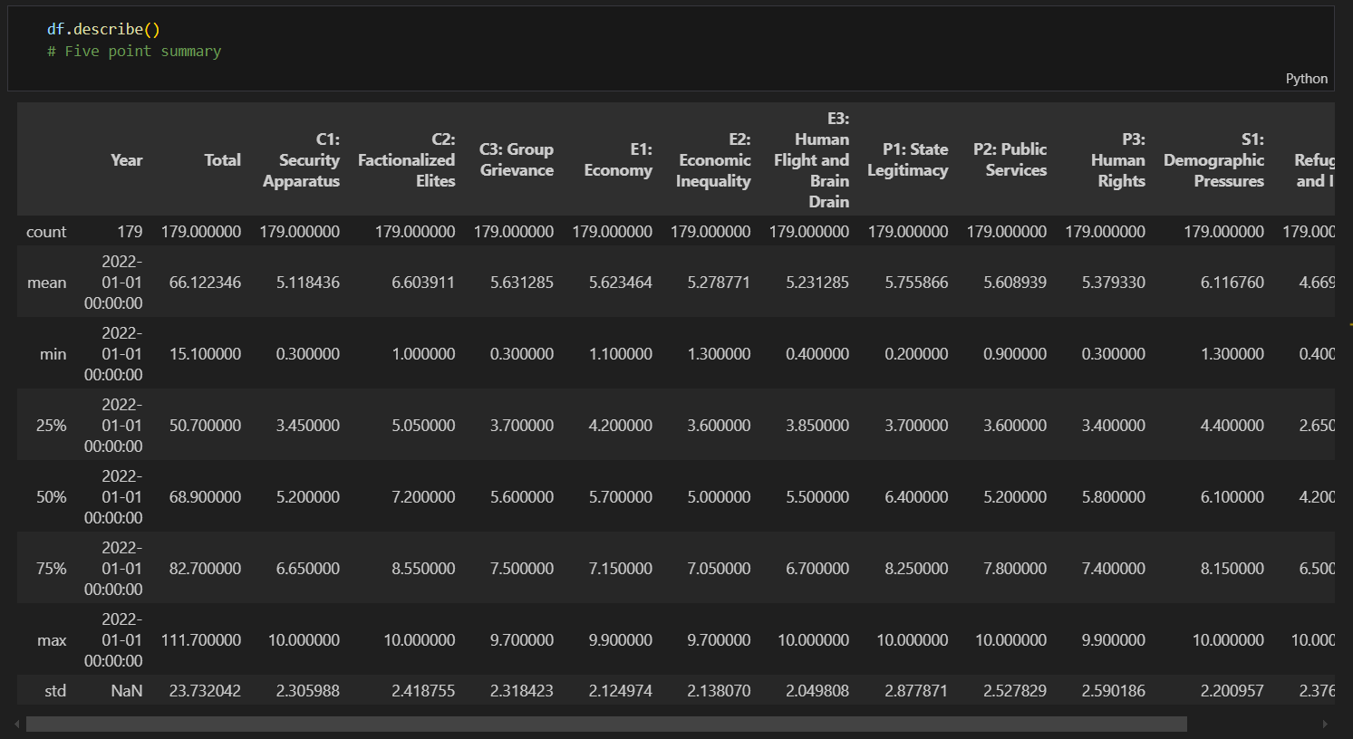

**Data Visualization:**

1. **Scatterplot Visualization**

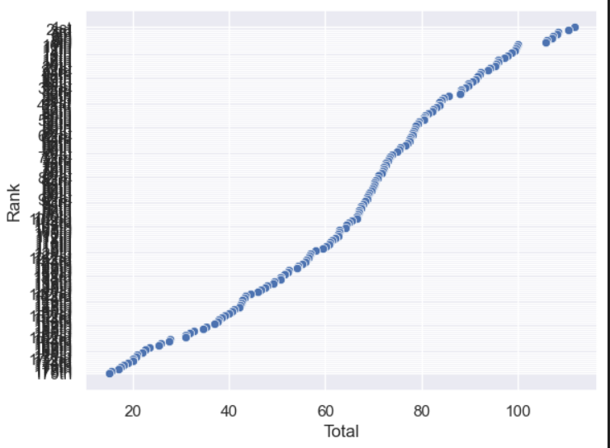

1. **Lineplot Visualization**

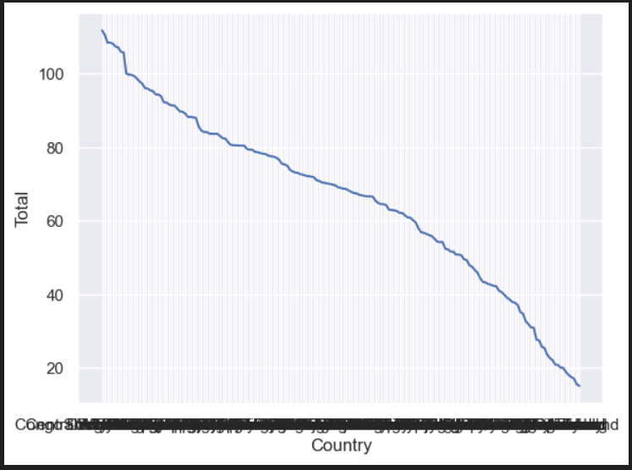

1. **Boxplot Visualization**

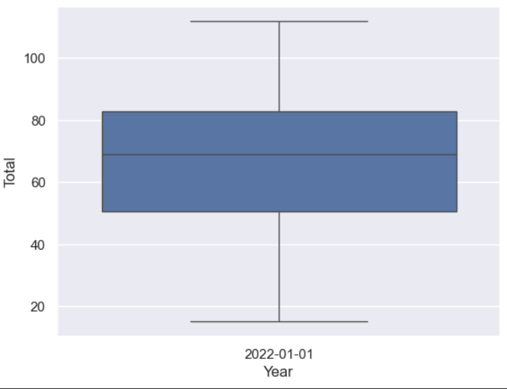

1. **Catplot Visualization**

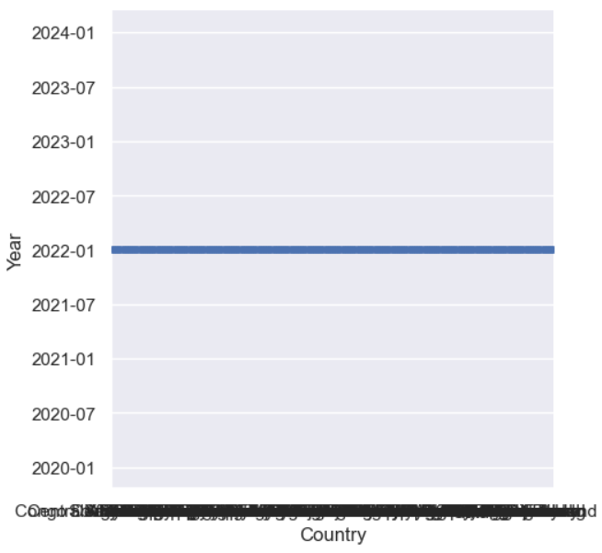

1. **Heapmap Visualization**

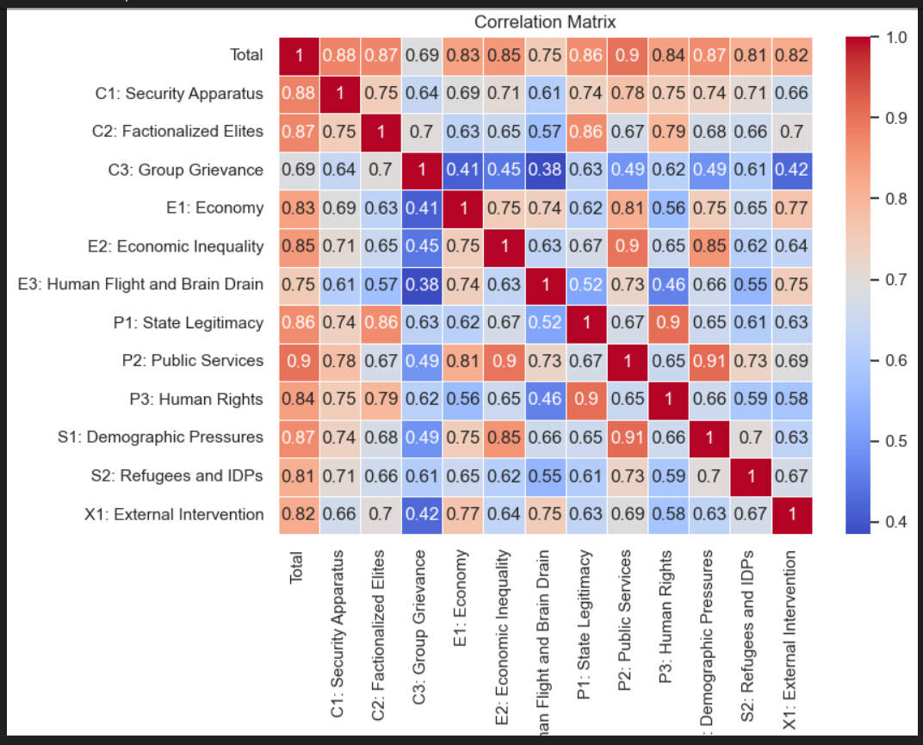

**Data Preprocessing**

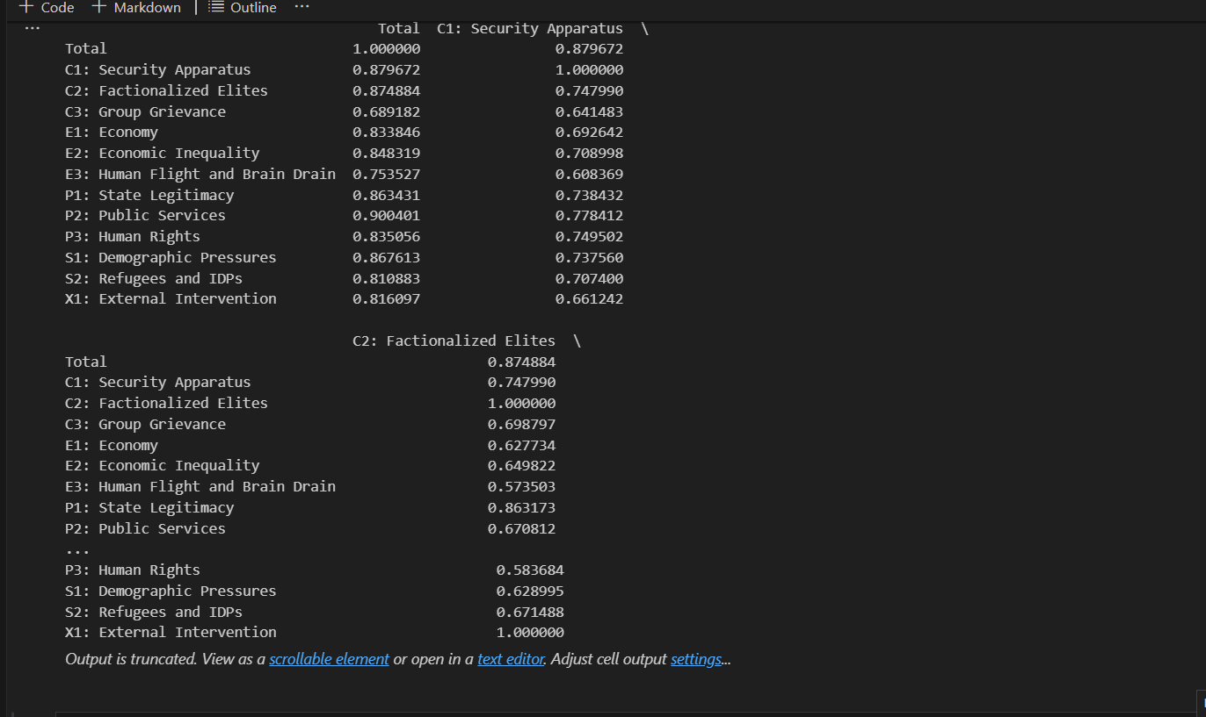

**Conclusion:**

The Fragile States Index provides a powerful tool for understanding the vulnerabilities and stability of countries worldwide. Through data preprocessing, visualization, and analysis, we gain valuable insights into the factors contributing to state fragility. As seen in the dataset, certain countries exhibit consistently high fragility scores, often due to political instability, economic decline, or social unrest. By identifying these vulnerable states, international organizations and policymakers can direct resources and support to mitigate risks and foster stability.

Further research can focus on refining the indicators used in the FSI, improving predictive models, and exploring deeper connections between fragility and other factors like climate change or international conflicts.